Designing Forms
Chapter
4

You can use the Form Wizard to create Forms very quickly. Once you know how to design forms you can use the forms created with a Wizard and customise them to your requirements.

In this section you will be designing forms from scratch. As you can see from the examples below you can do much more with forms when you know how to use the Design tools.
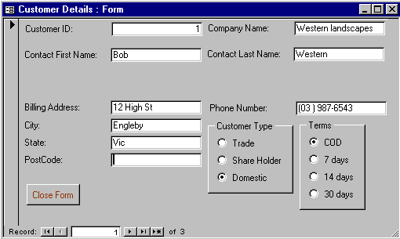
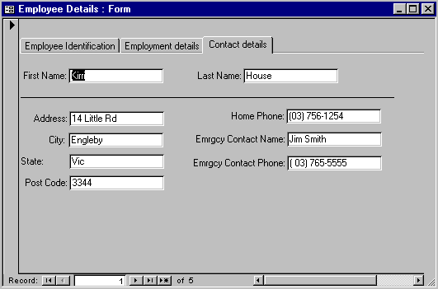
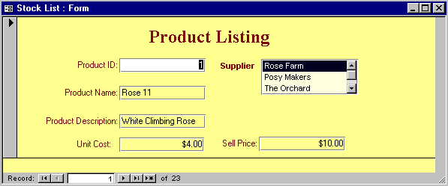

- Open the file Ch4 Form Design

Create a New Form from Scratch

- Click on the Form tab of the Database window if necessary
- Click on New
- Click on Design View if necessary
- Click on the "Choose the table…." box and scroll down and click on Stock
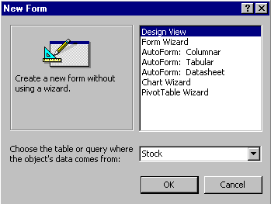
- Click on OK
Design view
Design view

A blank form appears ready for you to work with – the underlying data source is the Stock table.
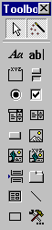
Forms Toolbox
Ruler
Grid
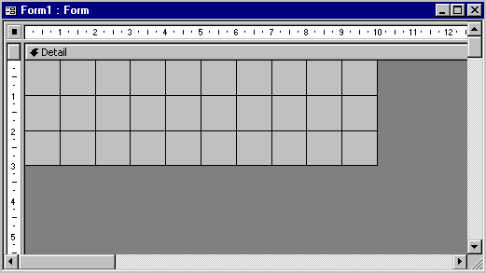

Note: The Forms Toolbox should also appear. If the toolbox does not appear click on View ➢ Toolbox in the Menu bar so the button appears pressed down on the menu bar.

Similarly the Ruler and Grid should also be visible – if they are not click on the View menu and click on the Ruler, or Grid to display that feature.

Adding Fields for the Form

This step is what the Wizard does so quickly – putting fields on the form. It takes a little longer when you do it manually.
Field List
- Click on the Field List button
The Fields for the Stock table you chose when creating the form will appear.
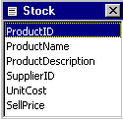

The fields you place on the form now will appear to the user when using the form.

- Click and hold the mouse on the ProductID field and drag it over to the form dropping it in the top left hand corner.

- Repeat for the other six fields.

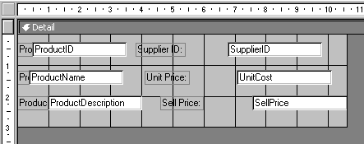

Note: You can also drop all the required fields onto the form at once simply by holding down the Ctrl key and selecting them then dragging over to the form.

Resizing the Form

Things seem to be a little crowded, you can resize a form either by widening, lengthening or both at the same time.

- Move the mouse down to the bottom right corner of the grid until it changes
- Click, hold and drag out and down to increase the size of the form to be about 5 cms by 13 cms, release the mouse

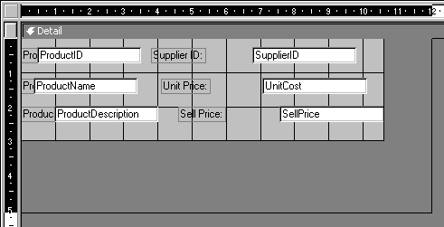

Moving Fields

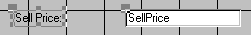
Each field has two parts. The Field box and the Field Label. The Field Box contains the contents of the field for the record displayed. The Field Label is simply a text label that can be changed to be more meaningful for the user if necessary.
Field Label
Field Box

- Click on either the Field Box or Field Label so the handles appear
- Move the mouse over the Field Label until it changes to a black hand
- Click, hold and drag down to another location
Both parts will move together
- Move the mouse over the top left corner of the label box until it turns into a pointing black hand

- Click, hold and drag the label towards the field box

This time only the label moves.

Selecting several Fields at once

You don’t have to work with the Field Boxes and Labels one at a time. You can select several at once and move them together so their position relative to one another remains the same. It also allows you to perform other actions simultaneously on the selected Boxes and Labels.

- Move the mouse pointer to be somewhere above the Supplier ID Label
- Click, hold and drag the mouse diagonally down to below the Sell Price Field Box
- Release the mouse – all Boxes and Labels in contact with the rectangle just drawn will be selected
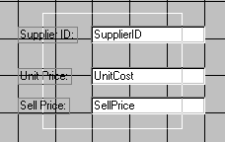
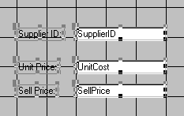

- Move the mouse over the border of one of the selected boxes until it changes to a hand

- Click hold and drag the mouse to move the boxes

Aligning Labels

Sometimes when moving objects around they can end up out of line. Objects can be lined up to the Left, Right, Top, Bottom or to the Grid.

- Select the Field Labels to be aligned

- Click on Format ➢ Align ➢ Left in the Menu bar
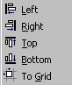
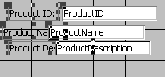
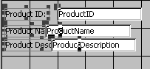

- Repeat to highlight the Field boxes and align them then drag them to the right so all are aligned and visible as shown on the following page

Spacing Fields

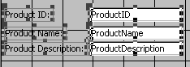
When several fields are selected they can be quickly aligned and spaced evenly.

With the fields selected as shown above

- Click on Format ➢ Vertical Spacing ➢ Make Equal in the Menu bar
- Click on Format ➢ Vertical Spacing ➢ Increase Spacing in the Menu bar
- Click on Format ➢ Vertical Spacing ➢ Decrease Spacing in the Menu bar
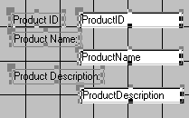

NOTE : If your fields end up looking like this it is because they weren't spread out horizontally

- Highlight the top two fields then Click on Format ➢ Align Top to have the field and its label perfectly aligned

To Delete a Text Box or Text Label

Any obect on the form can be deleted just by clicking on and pressing the [Delete] key.

- Click on the Unit Cost field and click on [Delete] on the keyboard

To View the Form

- Click on the View Form button

The form is displayed as it will appear to the user.

To Return to Design View

- Click on the View Design button in the toolbar

To Add a Label

A label is used to add Headings, notes or general information to a form. The text remains the same for any record displayed on the form.

- Highlight all the fields and move them down so there is space to insert a heading for the form
- Click on the Label button on the toolbox
- Move the mouse over the form to the top left corner of where the label is to appear then Click, hold and drag to create a box for the Label

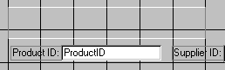
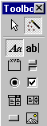
Label
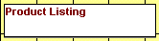
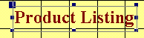
- The cursor will be flashing in the Label box – type Product listing
- Click outside the Label box
- Click on the Label box again to select it

Now you are ready to format the Label. You can use the formats available on the Format toolbar.
Font Type
Font Size
Font Style
Text Alignment
Fill Colour
Text Colour
Border Colour
Border Width
Special Effects

Formatting Controls

- Use the format buttons on the toolbar to format the Label box
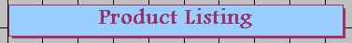

Add a Text Box

Text boxes can be bound or unbound. If unbound then the data that is entered in them is not stored in a table, it just appears on that form. A bound text box is bound to a field in a table so that the contents of that field appear in the form in that text box. Any data entered into a bound field will also be stored in the table.
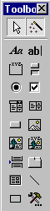
Text boxes
- Click on the Text box button on the Toolbox
- Click, hold and drag on the form where the text box is to appear

The text box and label will appear on the form with the
word Unbound

To Bind a Text box to a Field
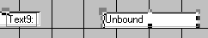

- Click on the Properties button on the toolbar

The Properties for the selected Text box will appear

- Click on the droplist button of the Control Source property
- Click on UnitCost
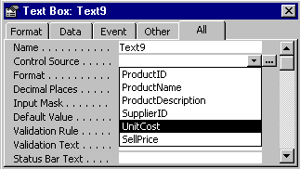
Unit Cost

- Click on the Name box on the All tab and type Unit Cost
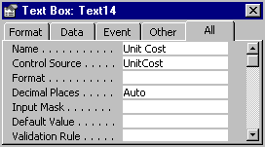

- Click on the Label object on the form – the Properties box will now display the Label properties

- Click in the Name box and type Unit Cost Label
- Click in the Caption and type Unit Cost – this is will appear on the form
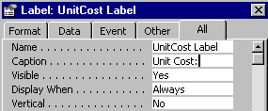

- Close the Properties box

Save a Form

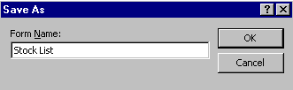
- Click on the Save button on the toolbar
- Type Stock List in the Save As box
- Click on OK

Using AutoFormat

You can use the AutoFormat feature to quickly format the form. But be aware that if you use the AutoFormat it will replace any formatting you have already applied.

- Click on Format ➢ AutoFormat in the Menu bar
- Click on Colourful 2 or one of the other AutoFormats
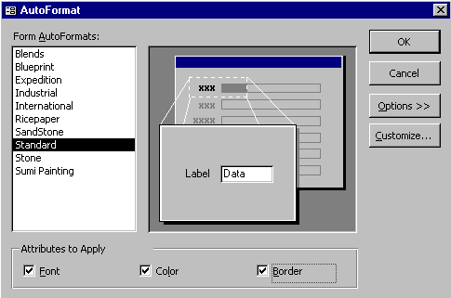
- Click on the Options button to display the Attributes to Apply checkbox
Options

- Click on each of the Attributes to Apply to turn them off and view the effect of not applying them – then turn them on again

- Click on OK to keep the settings and close the AutoFormat dialog box
- Save and Close the form

Practice 4.1:

- Create the following form in Design View based on the Customers table. Save it as Customer Details

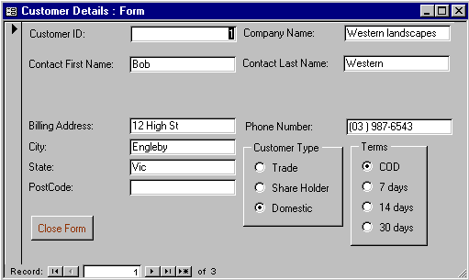

- Repeat to create a similar form for Suppliers

Creating an Option Group

An Option Group is where the user can use only one option. One option must be chosen but only one.

For example on the Customer Details form an Option Group could be used to record the Customer Type and Terms as shown below.

First you will create the Customer Type group.

- Click on the Option Group button on the Toolbox
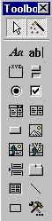
- On the form drag the mouse to create a rectangle area where the options will appear (use the layout above to guide you)
Option Group

- The Option Group Wizard will appear
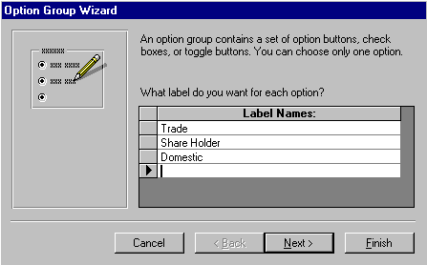
This step is where you list the Options you want. There are three Customer Types; Trade, Share Holder and Domestic

- Type Trade then press [Tab]
- Type Share Holder then press [Tab]
- Type Domestic then press [Tab]
- Click on Next

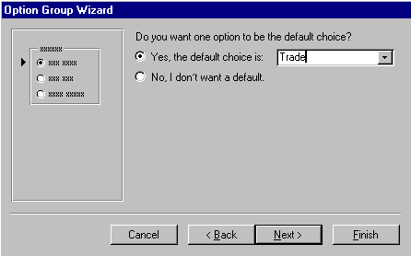
This step enables you to assign a Default option to the group so the most common option is already selected thus saving the user time in filling out the form.
- Trade already appears because it is the first in the group so leave it there

- Click on Next

When you use Options only a value is stored, eg 1, 2 or 3, not the actual Label name. This step enables you to assign a value to the Label Names.

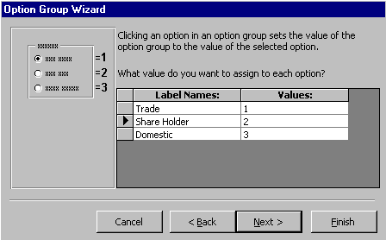
- Leave the values as 1, 2 and 3

- Click on Next

This step is to select in which field the values will be stored.

- Click on the droplist button and click on Type
- Click on Next
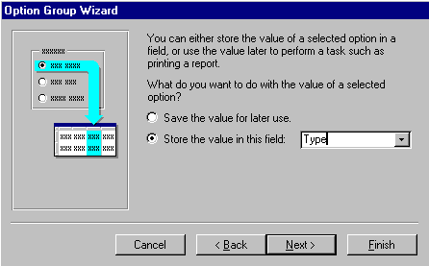
This step enables you to choose the type of buttons you want and the style. As you click on each selection you will be given a Sample preview on the left.

- Click on Option buttons
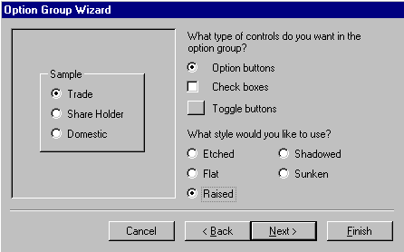
- Click on Raised for the style
Sample Preview

- Click on Next

This step enables you to give a heading for the group.
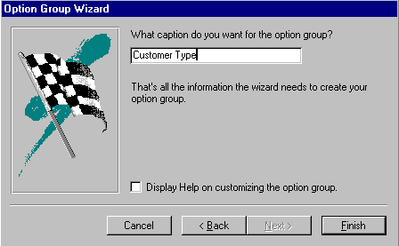
- Type Customer Type in the box

- Click on Finish
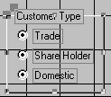

The Option group will appear on the form. The group can be moved and formatted as any other control.

Practice Exercise 4.2

- Repeat the whole process to create an Option Group for the Customers Terms.

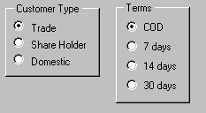

Your Customer Details form should look like this when you are finished.

Creating a Form with a Subform

In Chapter 3 Wizard Forms you used the Form Wizard to create a Form with a Subform.
Main Form
Sub Form
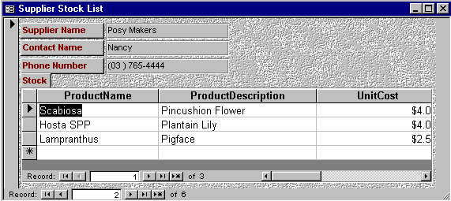
When designing these forms yourself you create the Main form first then insert the Subform.

Create the Main Form

- Create the following New form with the fields shown from the Orders table
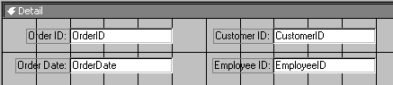

- Click, hold and drag the lower border of the form to increase the size of the form to be 11 cm deep

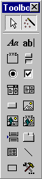
Create the Subform

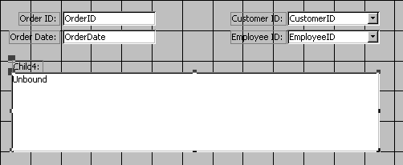
- Click on the Subform button and then drag the mouse to create a rectangle for the location of the subform on the main Orders form
Subform
The Subform/Subreport Wizard will commence as shown on the following page.
The first step is to determine if the Subform will be created from an existing table or query or from an existing form.
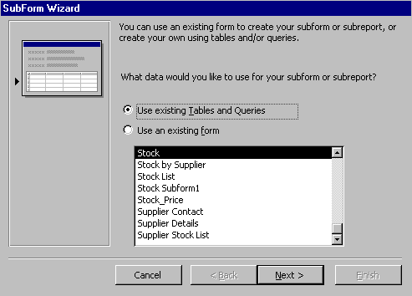
- Ensure Use existing Tables and Queries is selected
- Click on Next

This step is to determine which fields from the Table or Query are to be included in the subform.

- Click on the Tables and Queries box and select Query: OrderLines
- Click on each field in the Available Fields box and the Select Fields button to choose the selected fields as shown below
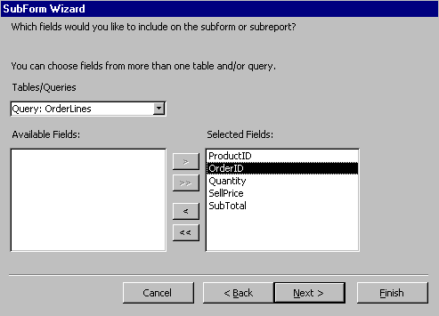
- Click on Next

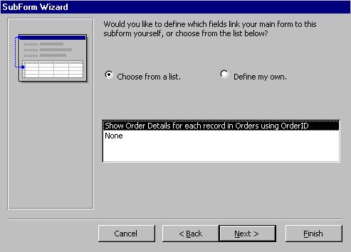
- Click on Next

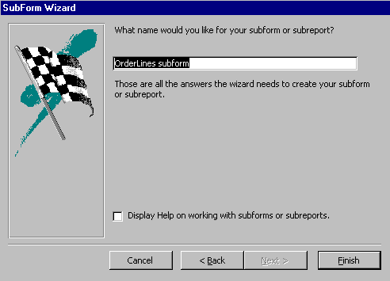
- Click on Finish
- Click on the Save button in the toolbar to save the form

- Name the form CustOrders and click on OK
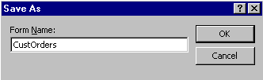

- Click on the Form View button to view the form as it will appear
You can resize the columns to be suitable widths.
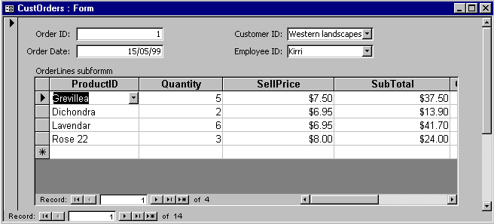

Practice Exercise 4.3

- Use the Design View to create the following Form/Subform

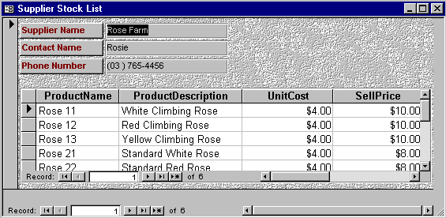

- Save it as Supplier Stock List

Create A Combo Box

A Combo box is useful if you do not have a lot of room on a form. It is similar to a lookup field in a table.
- Open the Design view of the CustOrders form

- Click on the Customer Id field and press the [Delete] key

- Click on the Combo button on the toolbox and draw a small rectangle on the form where Customer Id field appeared
Combo

The Combo Box wizard will start.

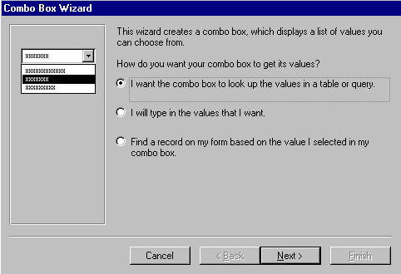
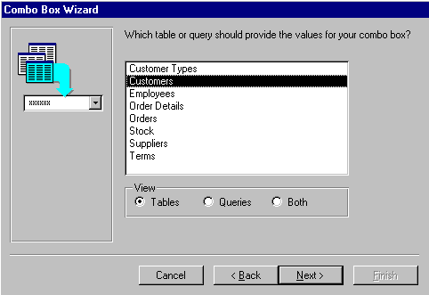
- Click on Next

- Click on the Customers table then click on Next

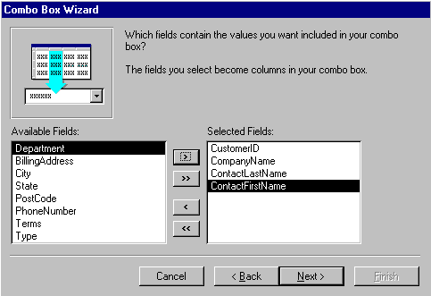
- Select the fields as shown to the left then click on Next

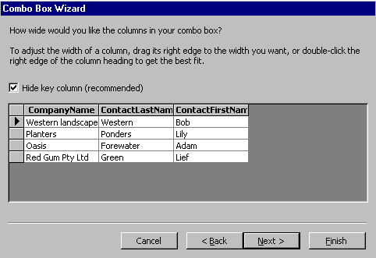

- Click on Next

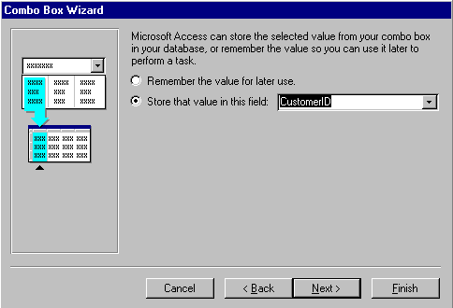
- Click on the CustomerID field

- Click on Next

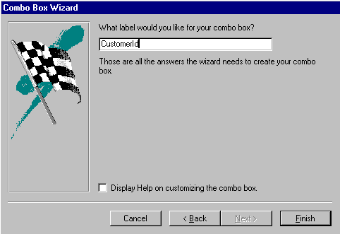

- Type CustomerId in the Label box

- Click on Finish

- Save the form

- Click on the Form View button to check the result
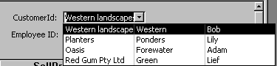

- Click on the droplist button in the CustomerID box to display Company and Contact details

- Repeat the whole process to place a combo box where the Employee Id field appears.
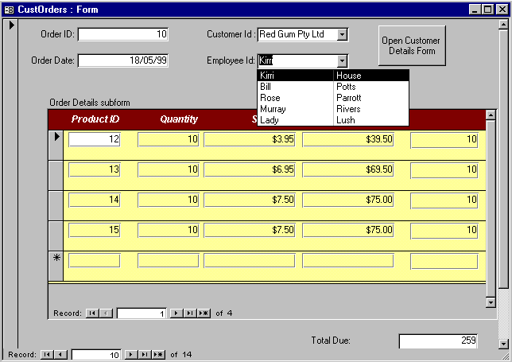

Using Tabs on a Form

Using Tabs on a form is a way of organising data.

- Start a New Form in Design View based on the Employees table
- Click on the Tab Control button and draw a large rectangle

Two “pages” are added to the form.

- Add the fields shown below to the Page1 tab
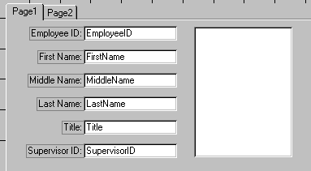
Tab Control

Naming Pages

- Click on the Properties button on the toolbar
- Click on the Other or All tab
- Type Employee Identification in the name box
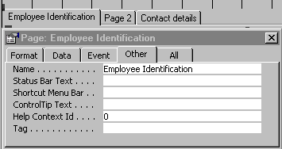

- Click on the Page 2 tab

- Change the name to Employment details
- Close the Properties box
- Add the fields as shown below to the second tab
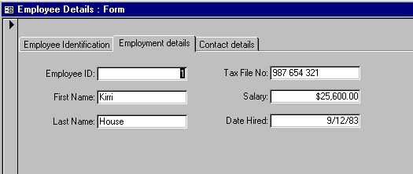

Inserting a Page

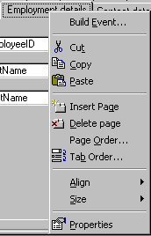
- Right Click on the Employment details tab and click on Insert Page

A new page will added to the form.

- Click on the Properties button
- Click in the Name box and type Contact Details

Practice Exercise 4.4

- Complete the tab shown below
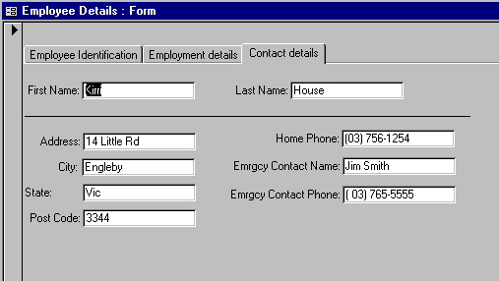
- Close the form saving the changes

Adding Command Buttons

- Open the CustOrders form in Design view
- Click on the Command button in the toolbox
- Draw a small rectangle for the button

The Command Button Wizard starts
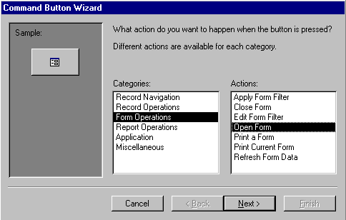

- Make the selections as shown above

- Click on Next
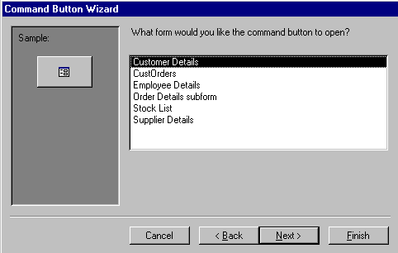

- Click on Customer Details if not already highlighted
- Click on Next

- Click on "Open the form and find specific data to display" because we only want the data for this specific customer displayed

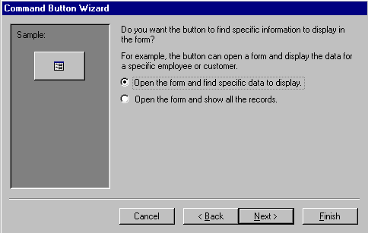

- Click on Next

- Make the selections as shown below
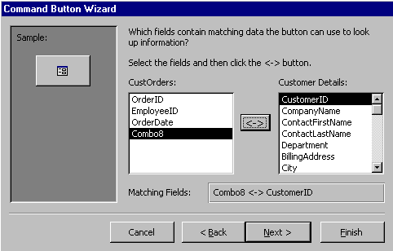

- Click on Next

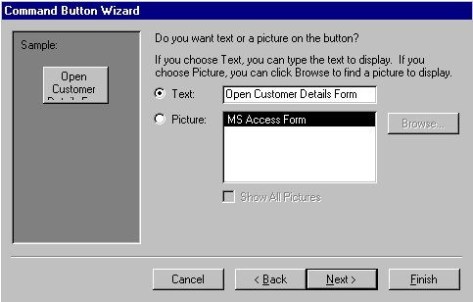
- Click on Next

- Type OpenCustForm in the text box so the button has a meaningful name
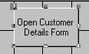
- Click on Finish

- Resize the button so it appears as shown here

- Save the form

- Click on Form View button to display the actual form

- Click on the "Open Customer Details Form" to display that form for the customer displayed.

Create a Close Form Button

- Click on the Design View button in the toolbar to display the Design of the Customer Details form

- Click on the Command button on the toolbox

- Click on Form Operations in the Categories box
- Click on Close Form in the Actions box
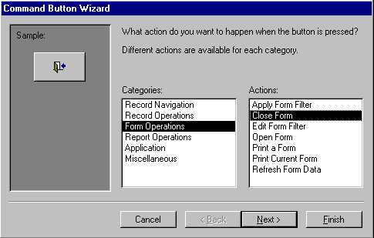

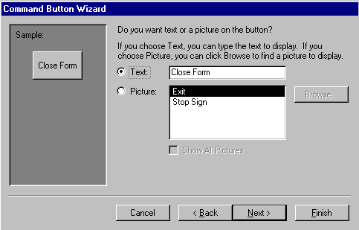
- Click on Next

- Click on Next

- Type Close Form as the name for the Control then click on Finish

- Repeat the process to put Close buttons on each of the Employees, Orders and Suppliers forms

Calculations on Forms

What we have done so far with forms is useful for display and data entry. However, look at the form below, it would be a lot more useful with a Total order value.

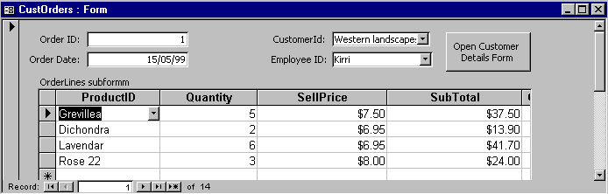
How about a total order value here!

This can be achieved by calculating the total on the Subform then “transferring” it onto the main Form.

- Close any open forms
- Click on the Orderlines Subform and the Design button
- Move the mouse down to the Form Footer until it changes to a double headed arrow – click , hold and drag the mouse down to create a space for the footer as shown below

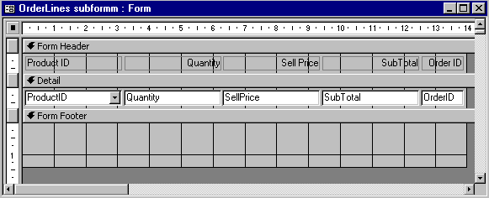

Text box
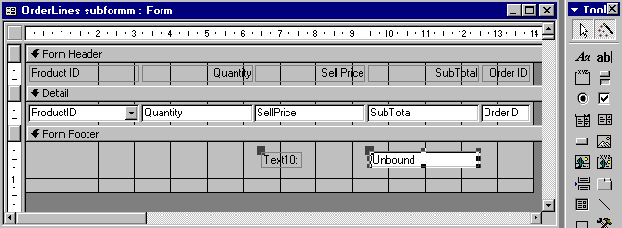
Delete label

- Click on the Text box button then click on the Form Footer below the Sub Total text box to place the box

- Click on the Label box and press the [Delete] key

- Click on the Unbound box to select it
- Click on the Properties button on the toolbar
- Click on the All tab of the Properties dialogue box
- Click in the Control Source box and type =Sum([SubTotal])
- Click in the Name box and delete any text there
- Type TotalOrder
- Click on Format and scroll down and click on Currency
- Click on the Decimal Places box and type 2
- Click on any other box to set the change
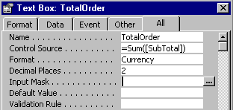
- Click on the Save button

- Close the form

The next step is display the expressions calculated on the subform on the main form.

- Click on the CustOrders form and click on the Design button

- Click on the Text box button then click on the Form Footer below the Sub Total text box to place the box

- Click on the Label box and type Total Due: as the new caption
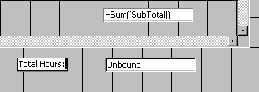
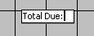
- Click on the Unbound box to select it
- Click on the Properties button on the toolbar
- Click on the All tab of the Properties dialogue box
- Click in the Name box and delete any text there
- Type OrderTotal
- Click on Format and scroll down and click on Currency
- Click on the Decimal Places box and type 2
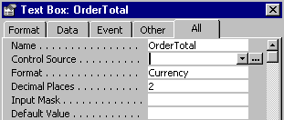
- Click on any other box to set the change

- Click in the Control Source box and click on the Expression builder button
- Type =
- Double click on the CustOrders folder
- Double click on the Orderlines subform folder
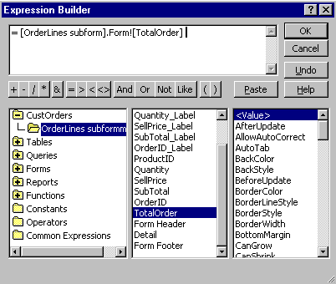
- Double click on TotalOrder – this is the box that contains the calculation of the Subtotal of each order

- Click on OK to close the Expression builder
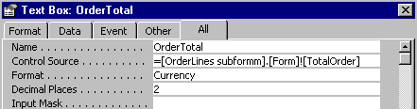
The expression appears in the Control Source box

- Close the Properties box
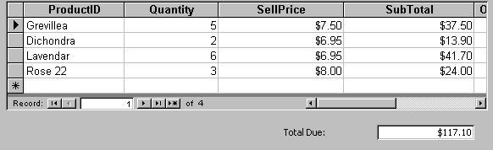
- Click on the Save button
- Click on the Form view button to check the results

- Use the Navigation buttons to display each order and check that the calculations are correct then close the form

